Eduardo Lopez
CS-1103 - Assignment 6
Assignment Codebase: https://github.com

Code:
Book.java
/**
* Book class - A specific type of LibraryItem for books
* Extends LibraryItem with String type parameter
*/
public class Book extends LibraryItem<String> {

/**
* Constructor for creating a Book item
* @param title The title of the book
* @param author The author of the book
* @param itemID Unique identifier for the book
*/
public Book(String title, String author, String itemID) {
super(title, author, itemID, "Book");
}
}

Catalog.java
import java.util.ArrayList;
import java.util.List;

/**
* Generic Catalog class that can store and manage different types of LibraryItems.
* This class demonstrates the use of generics to create a flexible library catalog system.
*
* @param <T> The type of LibraryItem this catalog will store (must extend LibraryItem)
*/
public class Catalog<T extends LibraryItem<?>> {
private List<T> items;
private String catalogName;

/**
* Constructor to create a new Catalog
* @param catalogName The name of this catalog
*/
public Catalog(String catalogName) {
this.catalogName = catalogName;
this.items = new ArrayList<>();
}

/**
* Adds a new item to the catalog
* @param item The LibraryItem to add
* @return true if the item was successfully added, false if item with same ID already exists
*/
public boolean addItem(T item) {
// Check if an item with the same ID already exists
if (findItemByID(item.getItemID()) != null) {
System.err.println("ERROR: An item with ID '" + item.getItemID() + "' already exists in the catalog.");
return false;
}

items.add(item);
System.out.println("✓ Item added successfully: " + item.getTitle());
return true;
}

/**
* Removes an item from the catalog by its ID
* @param itemID The ID of the item to remove
* @return true if the item was successfully removed, false if item not found
* @throws ItemNotFoundException if the item with the specified ID doesn't exist
*/
public boolean removeItem(String itemID) throws ItemNotFoundException {
T itemToRemove = findItemByID(itemID);

if (itemToRemove == null) {
throw new ItemNotFoundException("ERROR: Item with ID '" + itemID + "' not found in the catalog.");
}

items.remove(itemToRemove);
System.out.println("✓ Item removed successfully: " + itemToRemove.getTitle());
return true;
}

/**
* Retrieves an item from the catalog by its ID
* @param itemID The ID of the item to retrieve
* @return The LibraryItem if found, null otherwise
*/
public T getItem(String itemID) {
return findItemByID(itemID);
}

/**
* Helper method to find an item by its ID
* @param itemID The ID to search for
* @return The LibraryItem if found, null otherwise
*/
private T findItemByID(String itemID) {
for (T item : items) {
if (item.getItemID().equals(itemID)) {
return item;
}
}
return null;
}

/**
* Displays all items in the catalog in a formatted table
*/
public void displayCatalog() {
if (items.isEmpty()) {
System.out.println("\n═══════════════════════════════════════════════════════════════");
System.out.println(" The catalog is currently empty.");
System.out.println("═══════════════════════════════════════════════════════════════\n");
return;
}

System.out.println("\n╔════════════════════════════════════════════════════════════════════════════════╗");
System.out.println("║ " + catalogName.toUpperCase() + " ║");
System.out.println("╠════════════════════════════════════════════════════════════════════════════════╣");
System.out.println("║ Total Items: " + items.size() + " ║");
System.out.println("╚════════════════════════════════════════════════════════════════════════════════╝\n");

for (int i = 0; i < items.size(); i++) {
System.out.println((i + 1) + ". " + items.get(i).toString());
}
System.out.println();
}

/**
* Custom exception for when an item is not found in the catalog
*/
public static class ItemNotFoundException extends Exception {
public ItemNotFoundException(String message) {
super(message);
}
}
}

DVD.java
/**
* DVD class - A specific type of LibraryItem for DVDs
* Extends LibraryItem with String type parameter
*/
public class DVD extends LibraryItem<String> {

/**
* Constructor for creating a DVD item
* @param title The title of the DVD
* @param author The producer/studio of the DVD
* @param itemID Unique identifier for the DVD
*/
public DVD(String title, String author, String itemID) {
super(title, author, itemID, "DVD");
}
}

LybraryCatalogSystem.java
import java.util.Scanner;

/**
* LibraryCatalogSystem - Main class for the Generic Library Catalog application
* This class provides a command-line interface for managing a library catalog
* that can store different types of items (Books, DVDs, Magazines)
*
* CS 1103 - Programming Assignment Unit 8
* Generic Library Catalog System
*/
public class LibraryCatalogSystem {
private Catalog<LibraryItem<?>> catalog;
private Scanner scanner;
private boolean running;

/**
* Constructor - Initializes the catalog system
*/
public LibraryCatalogSystem() {
catalog = new Catalog<>("Library Catalog");
scanner = new Scanner(System.in);
running = true;
}

/**
* Main method - Entry point for the application
*/
public static void main(String[] args) {
displayWelcome();

LibraryCatalogSystem system = new LibraryCatalogSystem();
system.run();
}

/**
* Displays the welcome screen
*/
private static void displayWelcome() {
System.out.println("╔═══════════════════════════════════════════════════════════════╗");
System.out.println("║ ║");
System.out.println("║ GENERIC LIBRARY CATALOG SYSTEM ║");
System.out.println("║ CS 1103 - Programming Assignment Unit 6 ║");
System.out.println("║ ║");
System.out.println("║ A flexible catalog system using Java Generics ║");
System.out.println("║ Supporting: Books, DVDs, and Magazines ║");
System.out.println("║ ║");
System.out.println("╚═══════════════════════════════════════════════════════════════╝\n");
}

/**
* Main run loop for the application
*/
public void run() {
while (running) {
displayMenu();
int choice = getMenuChoice();
processMenuChoice(choice);
}

System.out.println("\n╔═══════════════════════════════════════════════════════════════╗");
System.out.println("║ ║");
System.out.println("║ Thank you for using our system! ║");
System.out.println("║ Goodbye! ║");
System.out.println("║ ║");
System.out.println("╚═══════════════════════════════════════════════════════════════╝\n");
}

/**
* Displays the main menu
*/
private void displayMenu() {
System.out.println("\n╔═══════════════════════════════════════════════════════════════╗");
System.out.println("║ MAIN MENU ║");
System.out.println("╠═══════════════════════════════════════════════════════════════╣");
System.out.println("║ 1. Add a New Item ║");
System.out.println("║ 2. Remove an Item ║");
System.out.println("║ 3. View Item Details ║");
System.out.println("║ 4. Display Entire Catalog ║");
System.out.println("║ 5. Exit ║");
System.out.println("╚═══════════════════════════════════════════════════════════════╝");
System.out.print("\nEnter your choice (1-5): ");
}

/**
* Gets the user's menu choice with error handling
* @return The validated menu choice
*/
private int getMenuChoice() {
try {
String input = scanner.nextLine().trim();
int choice = Integer.parseInt(input);

if (choice < 1 || choice > 5) {
System.err.println("ERROR: Please enter a number between 1 and 5.");
return 0;
}

return choice;
} catch (NumberFormatException e) {
System.err.println("ERROR: Invalid input. Please enter a number.");
return 0;
}
}

/**
* Processes the user's menu choice
* @param choice The menu option selected
*/
private void processMenuChoice(int choice) {
switch (choice) {
case 1:
addItem();
break;
case 2:
removeItem();
break;
case 3:
viewItemDetails();
break;
case 4:
displayCatalog();
break;
case 5:
running = false;
break;
default:
// Invalid choice already handled in getMenuChoice
break;
}
}

/**
* Adds a new library item to the catalog
*/
private void addItem() {
System.out.println("\n─────────── ADD NEW ITEM ───────────");
System.out.println("Select item type:");
System.out.println("1. Book");
System.out.println("2. DVD");
System.out.println("3. Magazine");
System.out.print("Enter type (1-3): ");

try {
int type = Integer.parseInt(scanner.nextLine().trim());

System.out.print("Enter Item ID: ");
String itemID = scanner.nextLine().trim();

if (itemID.isEmpty()) {
System.err.println("ERROR: Item ID cannot be empty.");
return;
}

System.out.print("Enter Title: ");
String title = scanner.nextLine().trim();

if (title.isEmpty()) {
System.err.println("ERROR: Title cannot be empty.");
return;
}

System.out.print("Enter Author/Publisher/Studio: ");
String author = scanner.nextLine().trim();

if (author.isEmpty()) {
System.err.println("ERROR: Author cannot be empty.");
return;
}

LibraryItem<?> item = null;

switch (type) {
case 1:
item = new Book(title, author, itemID);
break;
case 2:
item = new DVD(title, author, itemID);
break;
case 3:
item = new Magazine(title, author, itemID);
break;
default:
System.err.println("ERROR: Invalid item type.");
return;
}

catalog.addItem(item);

} catch (NumberFormatException e) {
System.err.println("ERROR: Invalid input. Please enter a number.");
} catch (Exception e) {
System.err.println("ERROR: Failed to add item: " + e.getMessage());
}
}

/**
* Removes an item from the catalog
*/
private void removeItem() {
System.out.println("\n─────────── REMOVE ITEM ───────────");

System.out.print("Enter Item ID to remove: ");
String itemID = scanner.nextLine().trim();

try {
catalog.removeItem(itemID);
} catch (Catalog.ItemNotFoundException e) {
System.err.println(e.getMessage());
}
}

/**
* Views detailed information about a specific item
*/
private void viewItemDetails() {
System.out.println("\n─────────── VIEW ITEM DETAILS ───────────");

System.out.print("Enter Item ID: ");
String itemID = scanner.nextLine().trim();

LibraryItem<?> item = catalog.getItem(itemID);

if (item == null) {
System.err.println("ERROR: Item with ID '" + itemID + "' not found.");
} else {
System.out.println("\n" + item.getDetailedInfo());
}
}

/**
* Displays the entire catalog
*/
private void displayCatalog() {
catalog.displayCatalog();
}
}

LibraryItem.java
/**
* Generic LibraryItem class that represents an item in the library catalog.
* This class can be extended or used to create different types of library items.
*
* @param <T> The type of the item (e.g., String for item type description)
*/
public class LibraryItem<T> {
private String title;
private String author;
private String itemID;
private T itemType; // Generic type for additional flexibility

/**
* Constructor to create a new LibraryItem
* @param title The title of the item
* @param author The author/creator of the item
* @param itemID The unique identifier for the item
* @param itemType The type of the item (Book, DVD, Magazine, etc.)
*/
public LibraryItem(String title, String author, String itemID, T itemType) {
this.title = title;
this.author = author;
this.itemID = itemID;
this.itemType = itemType;
}

// Getters and Setters
public String getTitle() {
return title;
}

public void setTitle(String title) {
this.title = title;
}

public String getAuthor() {
return author;
}

public void setAuthor(String author) {
this.author = author;
}

public String getItemID() {
return itemID;
}

public void setItemID(String itemID) {
this.itemID = itemID;
}

public T getItemType() {
return itemType;
}

public void setItemType(T itemType) {
this.itemType = itemType;
}

/**
* Returns a formatted string representation of the library item
* @return String containing item details
*/
@Override
public String toString() {
return String.format("ID: %-10s | Type: %-10s | Title: %-30s | Author: %s",
itemID, itemType, title, author);
}

/**
* Returns detailed information about the item
* @return Detailed string representation
*/
public String getDetailedInfo() {
StringBuilder info = new StringBuilder();
info.append("╔════════════════════════════════════════════════════════════════╗\n");
info.append("║ ITEM DETAILS ║\n");
info.append("╠════════════════════════════════════════════════════════════════╣\n");
info.append(String.format("║ Item ID: %-49s ║\n", itemID));
info.append(String.format("║ Type: %-49s ║\n", itemType));
info.append(String.format("║ Title: %-49s ║\n", title));
info.append(String.format("║ Author: %-49s ║\n", author));
info.append("╚════════════════════════════════════════════════════════════════╝");
return info.toString();
}
}

Magazine.java
/**
* Magazine class - A specific type of LibraryItem for magazines
* Extends LibraryItem with String type parameter
*/
public class Magazine extends LibraryItem<String> {

/**
* Constructor for creating a Magazine item
* @param title The title of the magazine
* @param author The publisher of the magazine
* @param itemID Unique identifier for the magazine
*/
public Magazine(String title, String author, String itemID) {
super(title, author, itemID, "Magazine");
}
}

LibraryCatalogTest.java
/**
* LibraryCatalogTest - Comprehensive testing for the Generic Library Catalog
* Tests all required functionalities including adding, removing, and retrieving items
*
* CS 1103 - Programming Assignment Unit 6
*
* To run this test: javac LibraryCatalogTest.java && java LibraryCatalogTest
*/
public class LibraryCatalogTest {

private static int totalTests = 0;
private static int passedTests = 0;

public static void main(String[] args) {
System.out.println("╔═══════════════════════════════════════════════════════════════╗");
System.out.println("║ GENERIC LIBRARY CATALOG - TEST SUITE ║");
System.out.println("║ CS 1103 - Programming Assignment Unit 6 ║");
System.out.println("╚═══════════════════════════════════════════════════════════════╝\n");

testAddingItems();
testRemovingItems();
testRetrievingItems();
testErrorHandling();
testGenericCompatibility();

displayTestSummary();
}

private static void testAddingItems() {
System.out.println("\n━━━ TEST 1: ADDING ITEMS ━━━\n");

Catalog<LibraryItem<?>> catalog = new Catalog<>("Test Catalog");

Book book1 = new Book("The Hobbit", "J.R.R. Tolkien", "B001");
test("Add Book", catalog.addItem(book1));

DVD dvd1 = new DVD("The Matrix", "Warner Bros", "D001");
test("Add DVD", catalog.addItem(dvd1));

Magazine mag1 = new Magazine("Science Today", "Science Press", "M001");
test("Add Magazine", catalog.addItem(mag1));

Book duplicateBook = new Book("Duplicate", "Unknown", "B001");
test("Reject Duplicate ID", !catalog.addItem(duplicateBook));
}

private static void testRemovingItems() {
System.out.println("\n━━━ TEST 2: REMOVING ITEMS ━━━\n");

Catalog<LibraryItem<?>> catalog = new Catalog<>("Test Catalog");
catalog.addItem(new Book("Book 1", "Author 1", "B100"));
catalog.addItem(new DVD("DVD 1", "Studio 1", "D100"));

try {
boolean removed = catalog.removeItem("B100");
test("Remove Existing Item", removed);
} catch (Exception e) {
test("Remove Existing Item", false);
}

try {
catalog.removeItem("NONEXISTENT");
test("Remove Non-existent (Exception Expected)", false);
} catch (Catalog.ItemNotFoundException e) {
test("Remove Non-existent (Exception Caught)", true);
}
}

private static void testRetrievingItems() {
System.out.println("\n━━━ TEST 3: RETRIEVING ITEMS ━━━\n");

Catalog<LibraryItem<?>> catalog = new Catalog<>("Test Catalog");
Book testBook = new Book("Test Book", "Test Author", "B200");
catalog.addItem(testBook);

LibraryItem<?> retrieved = catalog.getItem("B200");
test("Retrieve Existing Item", retrieved != null && retrieved.getItemID().equals("B200"));

LibraryItem<?> notFound = catalog.getItem("INVALID");
test("Retrieve Non-existent Returns Null", notFound == null);

boolean detailsCorrect = retrieved != null &&
retrieved.getTitle().equals("Test Book") &&
retrieved.getAuthor().equals("Test Author");
test("Item Details Match", detailsCorrect);
}

private static void testErrorHandling() {
System.out.println("\n━━━ TEST 4: ERROR HANDLING ━━━\n");

Catalog<LibraryItem<?>> catalog = new Catalog<>("Test Catalog");

try {
catalog.removeItem("B999");
test("Remove from Empty (Exception Expected)", false);
} catch (Catalog.ItemNotFoundException e) {
test("Remove from Empty (Exception Caught)", true);
}

catalog.addItem(new Book("Book 1", "Author", "B500"));
boolean duplicate = catalog.addItem(new Book("Book 2", "Author", "B500"));
test("Duplicate ID Rejected", !duplicate);

try {
catalog.removeItem("B500");
catalog.removeItem("B500");
test("Multiple Removals (Exception Expected)", false);
} catch (Catalog.ItemNotFoundException e) {
test("Multiple Removals (Exception Caught)", true);
}
}

private static void testGenericCompatibility() {
System.out.println("\n━━━ TEST 5: GENERIC COMPATIBILITY ━━━\n");

Catalog<LibraryItem<?>> catalog = new Catalog<>("Mixed Catalog");
boolean added1 = catalog.addItem(new Book("Book", "Author", "B600"));
boolean added2 = catalog.addItem(new DVD("DVD", "Studio", "D600"));
boolean added3 = catalog.addItem(new Magazine("Magazine", "Publisher", "M600"));
test("Mixed Item Types Added", added1 && added2 && added3);

LibraryItem<?> book = catalog.getItem("B600");
LibraryItem<?> dvd = catalog.getItem("D600");
LibraryItem<?> mag = catalog.getItem("M600");
test("Retrieve Different Types", book != null && dvd != null && mag != null);

boolean correctTypes = (book instanceof Book) &&
(dvd instanceof DVD) &&
(mag instanceof Magazine);
test("Type Checking", correctTypes);

System.out.println("\n━━━ CATALOG DISPLAY TEST ━━━");
catalog.displayCatalog();
}

private static void test(String testName, boolean condition) {
totalTests++;
if (condition) {
passedTests++;
System.out.println("✓ PASSED: " + testName);
} else {
System.err.println("✗ FAILED: " + testName);
}
}

private static void displayTestSummary() {
System.out.println("\n╔═══════════════════════════════════════════════════════════════╗");
System.out.println("║ TEST SUMMARY ║");
System.out.println("╠═══════════════════════════════════════════════════════════════╣");
System.out.println(String.format("║ Total Tests: %-44d ║", totalTests));
System.out.println(String.format("║ Passed Tests: %-44d ║", passedTests));
System.out.println(String.format("║ Failed Tests: %-44d ║", (totalTests - passedTests)));

double successRate = (totalTests > 0) ? (passedTests * 100.0 / totalTests) : 0.0;
System.out.println(String.format("║ Success Rate: %.2f%%%-40s ║", successRate, ""));
System.out.println("╚═══════════════════════════════════════════════════════════════╝");

if (passedTests == totalTests) {
System.out.println("\n✓ ALL TESTS PASSED! The catalog system works correctly.\n");
} else {
System.err.println("\n✗ Some tests failed. Review the implementation.\n");
}
}
}

Output:
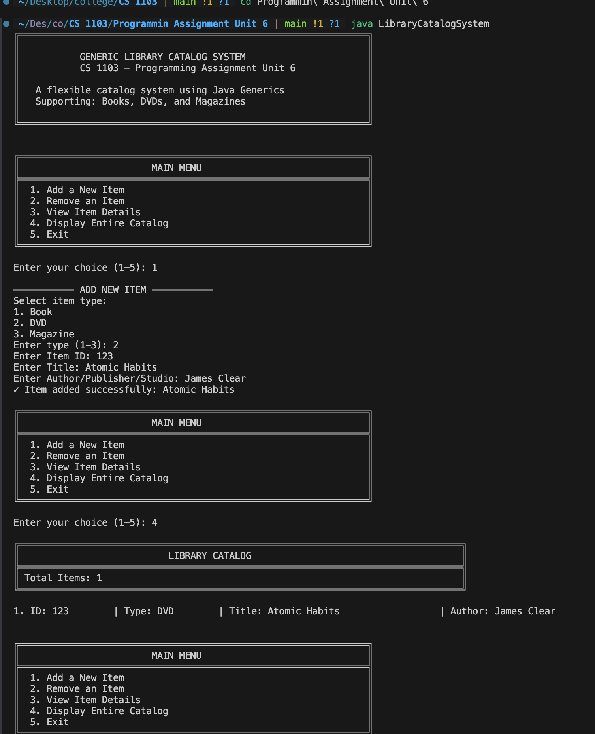
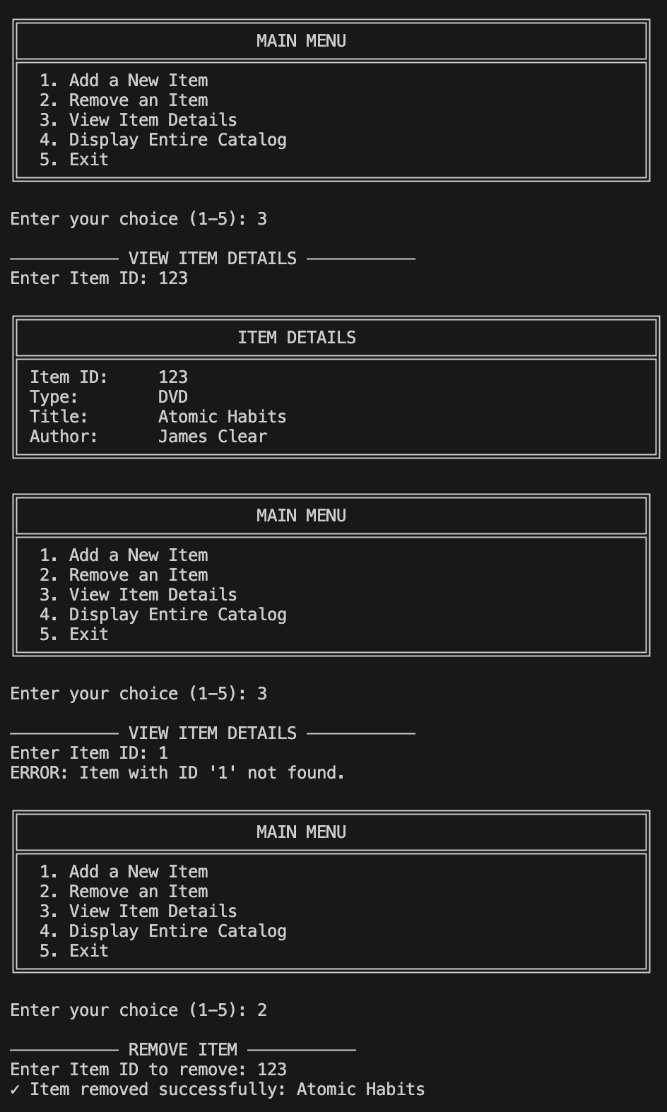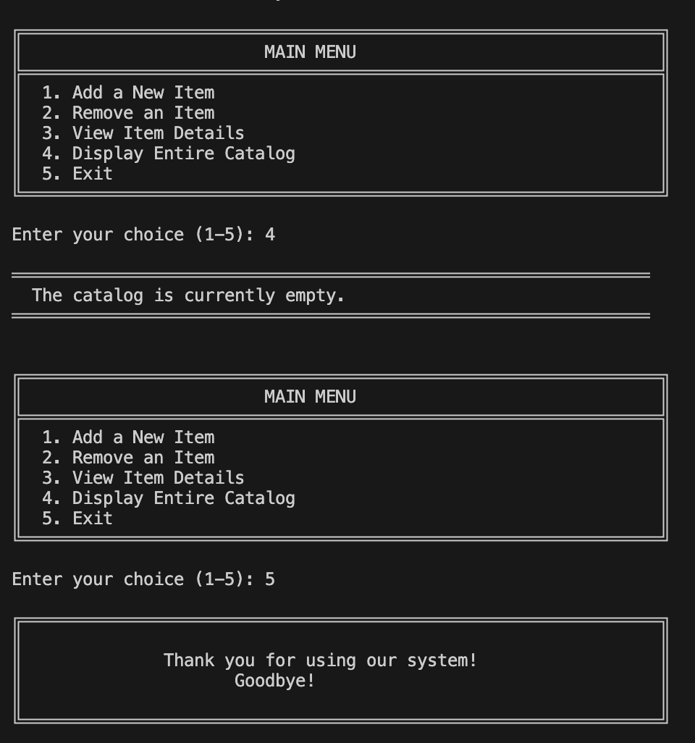

Test
